- TURN ON APPLICATION AND LOG IN
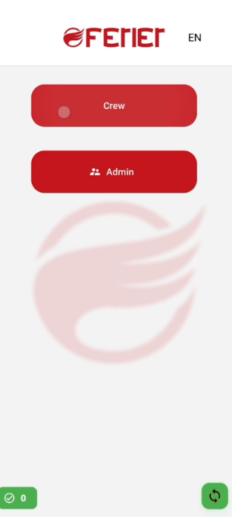
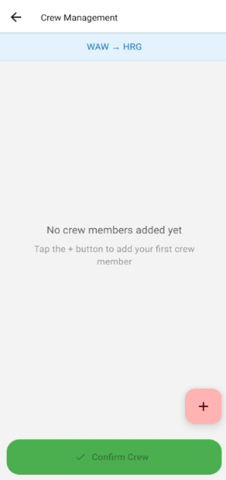
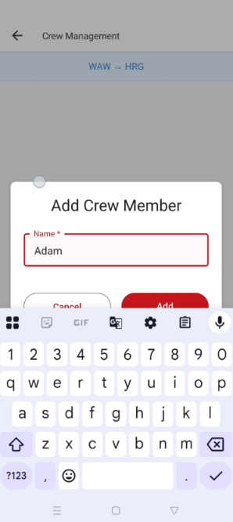
- Turn on Ferier BOB application
- Push button CREW
- Push button „+”
- Type name than click ADD
- Add as many member as you
Need (it will be necessary when
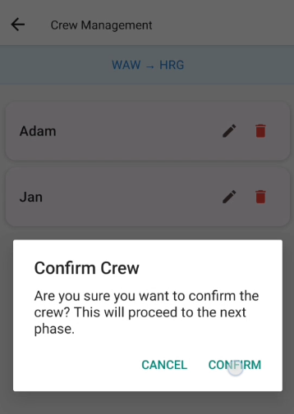
- Confirm crew by clicking confirm

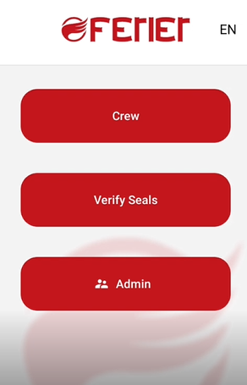

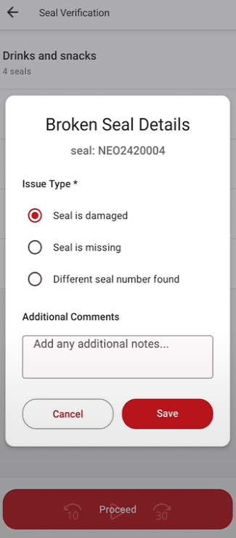
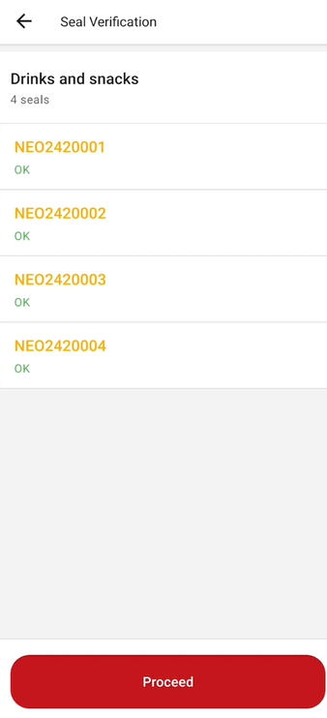
- VERYFING SEALS
- Click on Verify Seals
- Check seals if seals are broken
Click on seal and put reason, if
All seals are ok than clik
“Proceed”

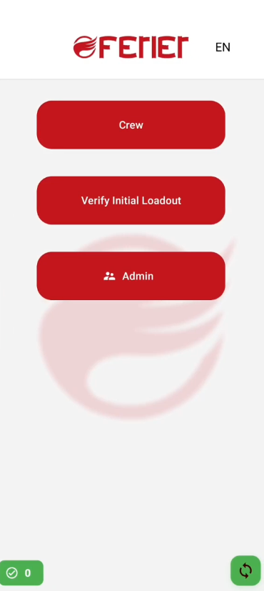
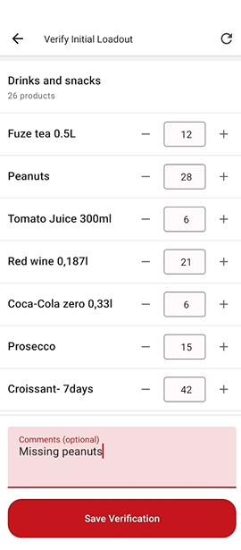
- INVENTORY CHECK
- Click on “Verify Initial Loading”
- Adjust numbers and optionally put
comments.
- Click “Save Verification”

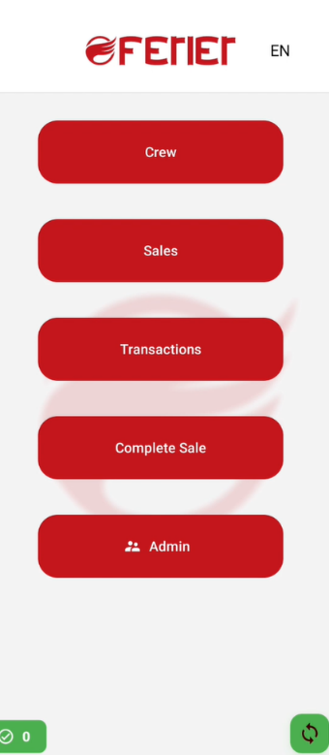
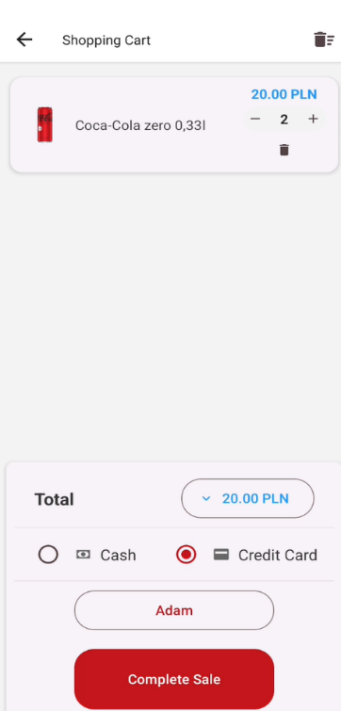
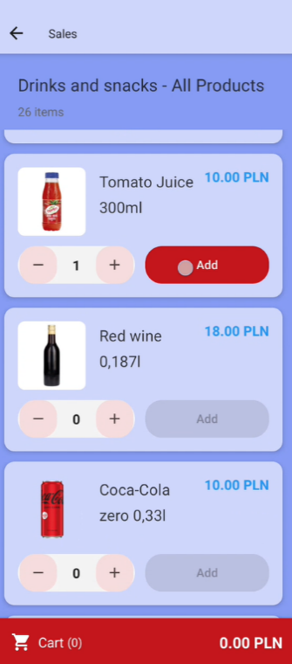
- SALES
- Click on “SALES”,
- Choose category of items
- Click “+” to increase amount of
Sale, then click “ADD”
- You can add multiple items for sale
- Then click “CART”
- Choose payment term and
Click “Compleat sale”

- Then automatically payment terminal
Will open application to pay on terminal.
Please follow information on screen.

- On section “Transactions” you can check transactions
Or do transaction refund.
Attention: it is possible to refund all costs of one transactions.
For example: If a customer purchased two cans of Coca-Cola and wishes to return one, the entire transaction for both items must be cancelled and then re-entered for a single item.

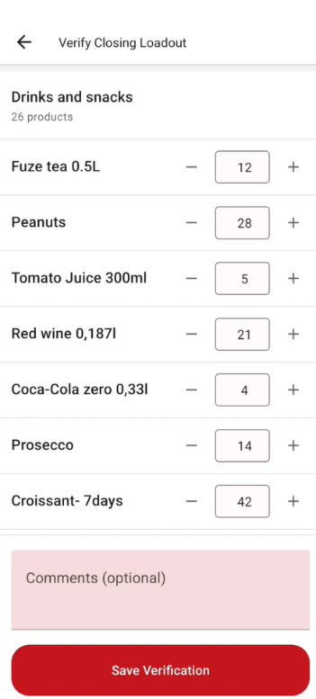
- Sale complete
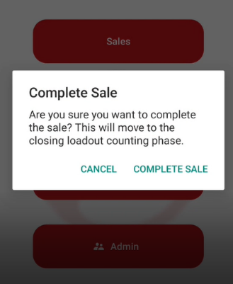
- To finish sale – please click
“Complete sale” you need
To double confirm on second
Window.
Attention:
After double confirmation
It won’t be possible to revert
to sale.

- Verify closing stock, by clicking
“save verification” or adjust
numbers.

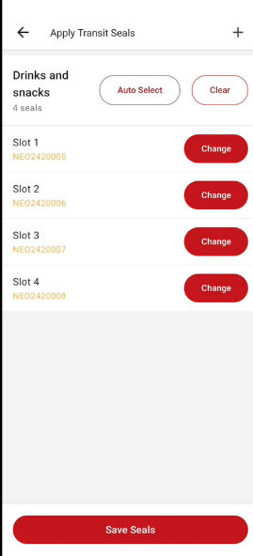
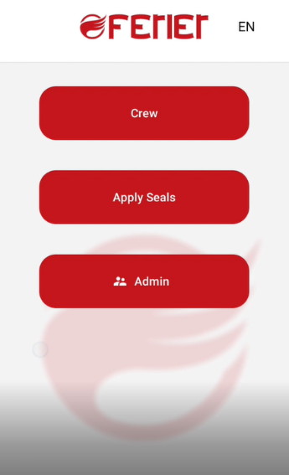
- Apply seals –
Click on apply seals and
Auto select to add seals to system.
You can also adjust manually
Seal no. by clicking change.
Confirm seales by clicking
“save”

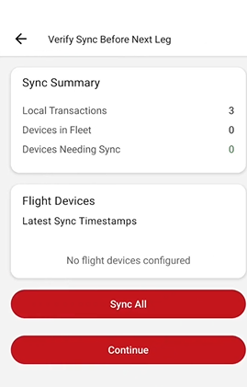
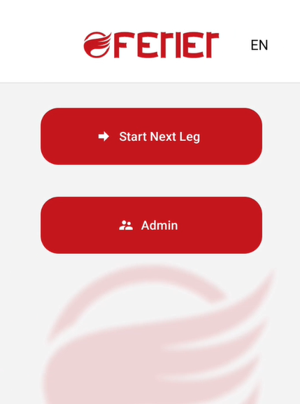
- Crew swap – next leg.
To start sales on next leg just
Click on button “star next leg”
Than “Sync all”
And proceed in accordance with
the instructions starting from point one.

